When a car entry is at 7:00 a.m. on Tuesday,12 November and exit is at 4:00 p.m. on the same day. Early Bird charges are applied for the parking

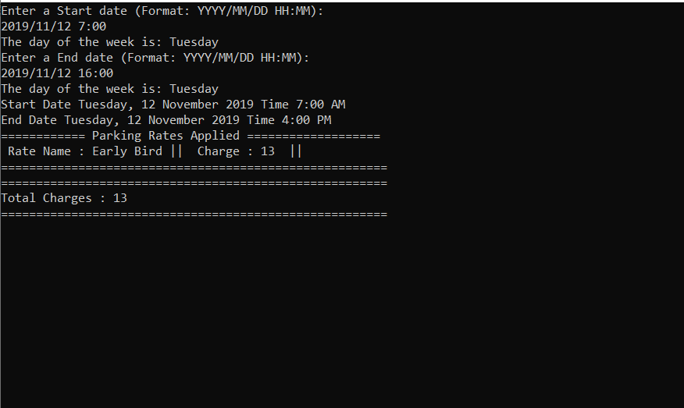

When car is parked at 7:00 p.m. on Friday, 8th November and exit at 4:00 p.m. on Saturday, 9th November. Night rate charges are applied for the parking.

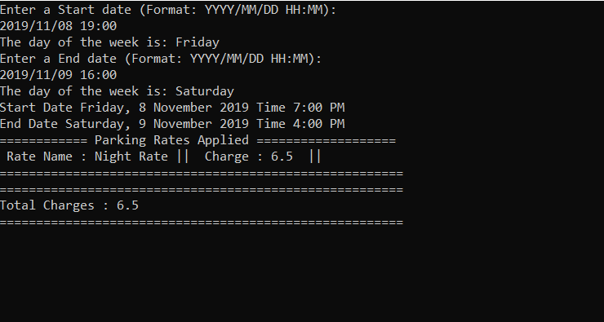

When a car entry is at 2019/11/08 12:30 p.m. and exit on 2019/11/13 01:30 a.m., the user is charged parking fee of 80 dollars.

$20 for Friday (Standard Rate for more than 4 hours); $10 dollar for Saturday + Sunday (10 dollars for the whole weekend); Standard Rates of 20 dollar on Monday and Tuesday;10 dollars for 1-2 hours parking.

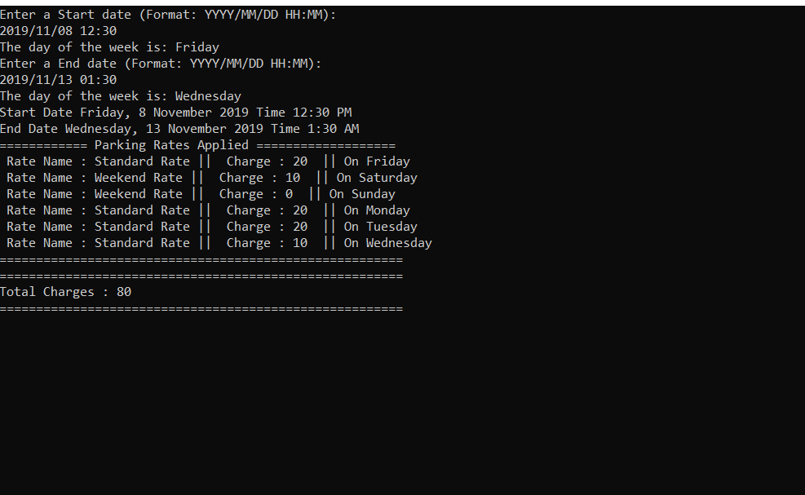

When a car entry is on Friday 12:30 p.m. and exit is at 05:30 a.m. on Saturday, the user is charged 30 dollars (20 dollars Standard Rate for Friday and 10 dollars for Saturday)

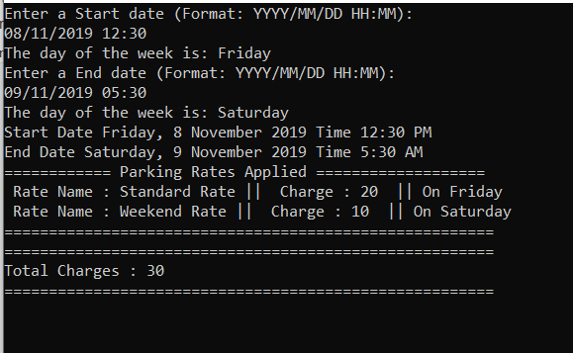

Parking at 12:30 on Saturday and exit at 02:30 a.m. on Sunday, Weekend Rate is applied and charged 10 dollars

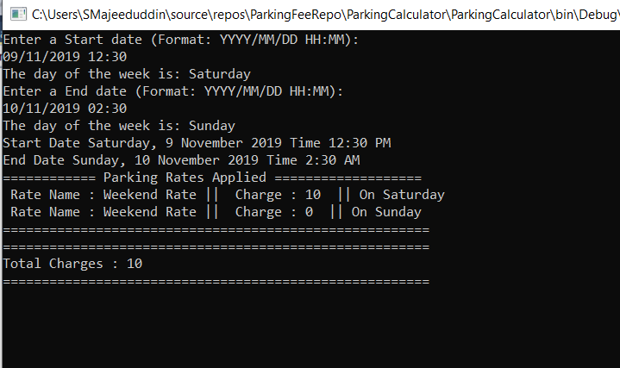

Parking for half an hour on a weekend will be charged flat 10 dollar Weekend Rate

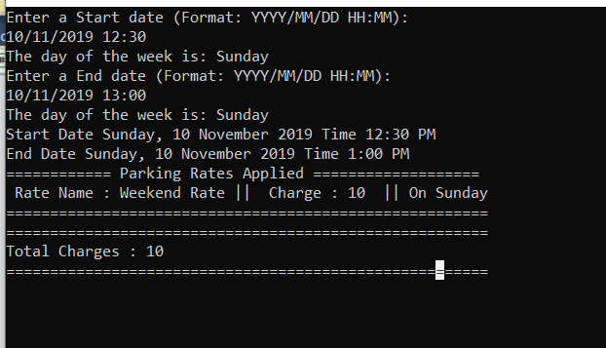

3-hour parking on Weekday is charged 15 dollars.

